iMITS Release Notes

**Deployed Date:** 09/01/2018

**Features**

**Feature**: Excel report of Cas9 Micro Injections

**Description**: This report displays all Cas9 Micro injection (including Electroporations). The data is split across multiple spreadsheet. The spreadsheets display the following information.

1. Microinjection design and setup, Microinjection efficiency matrixes, Founder Screen counts
2. F1 Colonies, allele categorization; allele sequence and QC

The report tries to indicate which information is missing/incomplete and which information looks suspect and should be checked and corrected. The report does this by highlighting missing data in red and suspect data in orange.

The report also included auto filters and frozen windows to make it easier for the user to explore their data and filter their data as they wish. Prior to generation the user has the option to only select the data for their center. If not used the report will include the data from all centers.

**PLEASE NOTE** Excel has a character limit on the cells of 32,000 characters. Therefore F1 colonies sequences may not be complete.

**Navigation to the reports:**

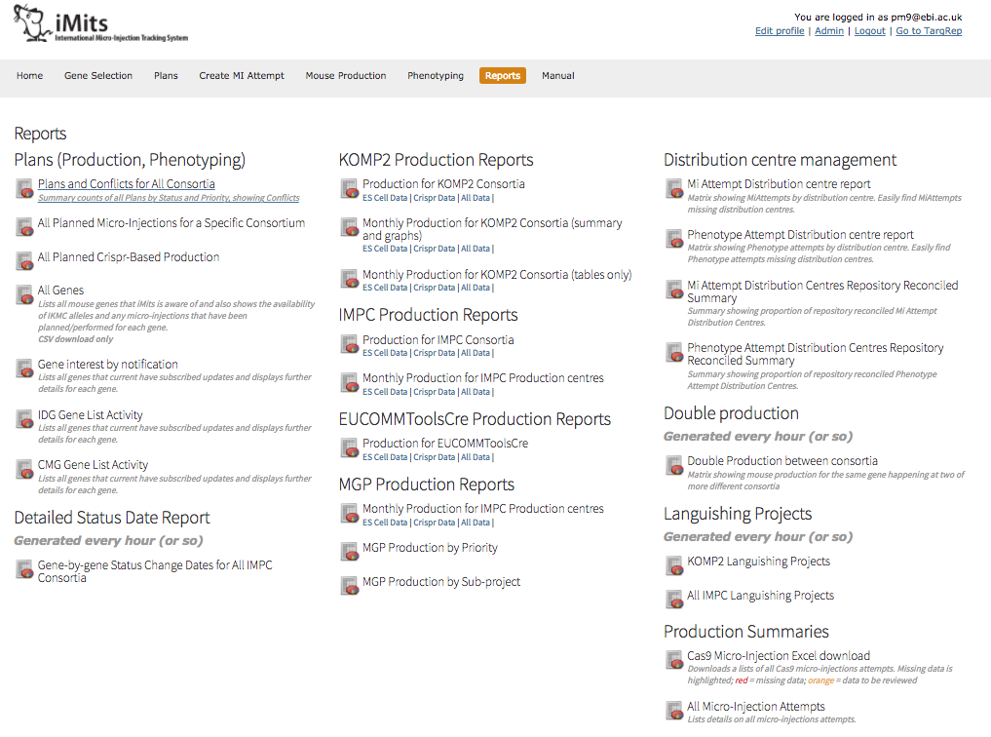

* Navigate to the report tab.
* The report can be found under the ‘Production Summaries’ section.
* Clicking on the report will take you to another page which will allow you to generate the report.
* You can generate the 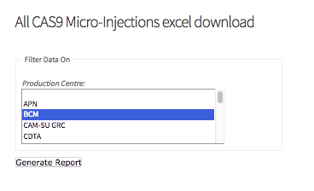report solely for your center by selecting your centers name in the drop down before clicking the generate button. The report will take approximately 15 seconds to generate, please be patient.